

Bachelor of Computer Application (BCA) Programme

Minor Project Report

BCA Sem V

AY 2022-23

*Online Addmission System*

*by*

|  |  |  |
| --- | --- | --- |
| Exam No. | Roll No. | Name of Student |
| 4205 | 184 | Shah Malay A. |

**Project Guide by:**

Prof. Nehal Patel

*I N D E X*

|  |  |  |
| --- | --- | --- |
| **Sr. No** | **Description** | **Page No.** |
| 1 | Introduction |  |
|  | 1.1 Project description | 1 |
|  | 1.2 Project Profile | 2 |
| 2 | Environment Description |  |
|  | 2.1 Hardware and Software Requirements | 3 |
|  | 2.2 Technologies Used | 4 |
| 3 | System Analysis and Planning |  |
|  | 3.1 Existing System and its Drawbacks | 5 |
|  | 3.2 Feasibility Study | 6 |
|  | 3.3 Requirement Gathering and Analysis | 8 |
| 4 | Proposed System |  |
|  | 4.1 Scope | 10 |
|  | 4.2 Project modules | 11 |
|  | 4.3 Module vise objectives/functionalities Constraints | 11 |
| 5 | Detail Planning |  |
|  | 5.1 Data Flow Diagram / UML | 13 |
|  | 5.2 Process Specification / Activity Flow Diagram | 15 |
|  | 5.3 Data Dictionary | 16 |
|  | 5.4 Entity-Relationship Diagram / Class Diagram | 18 |
| 6 | System Design |  |
|  | 6.1 Database Design | 19 |
|  | 6.2 Directory Structure | 21 |
|  | 6.3 Input Design | 22-24 |
|  | 6.4 Output Design | 25-27 |
| 7 | Software Testing | 28 |
| 8 | Limitations and Future Scope of Enhancements | 30 |
| 9 | References | 31 |

**Introduction**

**1.1 Project description**

The admission management system is software that enables educational institutions to conduct student admission and enrolment procedures online. The admission management system manages student admission form collection, collects documents, and shortlists candidates to complete the admission process online.

The increasing numbers of students seeking admission in the academic institutes (School, Colleges, and Universities) are causing tremendous pressure on the administrative body of the institutes to manage and arrange the admission process manually. It is difficult now to conduct the process accurately and in a timely manner. Hence, the need for online admission is inevitable.

The aim of the study is to analyze the current admission system and suggest an online admission system which will allow people to cast admission on a more convenient way, by using available resources which could facilitate the students during online admission.

**1.2 Project Profile**

|  |  |
| --- | --- |
| **Project Title** | Online Admission System |
| **Definition** | Online Admission systems are software platforms used to securely conduct Admission. As a digital platform, they eliminate the need to cast your admission using paper or having to gather in person.  They also protect the integrity of your admission by preventing students from being able to admission multiple times. |
| **Developed For** | SDJ International College, Vesu, Surat |
| **Project Guide(s)** | Prof. Nehal Patel |
| **Front End** | Notepad++, Visual Studio Code |
| **Scripting language** | Html, CSS, Bootstrap |
| **Back End** | PHP, MySQL, Xampp Server |
| **Operating System** | Microsoft Windows 10/11 |
| **Tools used for ERD & DFD** | Microsoft Word, Draw.io, Visio |
| **Submitted By** | Shah Malay Ashwinkumar (4205) |

**Environment Description**

**2.1 Hardware and Software Requirements**

**Hardware Requirements:**

|  |  |
| --- | --- |
| **Browser** | Microsoft Internet Explorer, Mozilla Firefox and Google Chrome |
| **Operating System** | Windows 10 and Windows 11 |
| **Front End** | Html, CSS |
| **Back End** | Php, MySQL |
| **Other Tools** | Microsoft Word, Draw.io, Visio. |

**Software Requirements:**

|  |  |
| --- | --- |
| **Processor** | 11th Gen IntelR Core™ i5-1135G7 @ 2.40GHz 2.42GHz |
| **RAM** | 8.00 GB |
| **Hard Disk** | 1.00 TB |
| **System Type** | 64-bit Operating System, x64-Based Processor |

**2.2 Technologies Used**

**Hardware Requirements:**

|  |  |
| --- | --- |
| **Processor** | 11th Gen IntelR Core™ i5-1135G7 @ 2.40GHz 2.42GHz |
| **Memory** | 8.00 GB |
| **Hard Disk** | 1.00 TB |
| **System Type** | 64-bit Operating System, x64-Based Processor |

**Software Requirements:**

|  |  |
| --- | --- |
| **Operating System** | Windows 10 and Windows 11 |
| **Front End** | Html, CSS, JavaScript, Bootstrap |
| **Back End** | PHP, MySQL |
| **Input Device** | Keyboard, Mouse |
| **Output Device** | Monitor |
| **Browser** | All Modern Browsers |

**System Analysis and Planning**

**3.1 Existing System and its Drawbacks**

An [online Admission system](https://electionbuddy.com/features/online-voting/) is a platform that allows organizational members to cast their Admission electronically, which can be through a website or any internet-connected device.

You can conduct various types of admission through an online admission system. For example, you can use it for a simple majority admission, where the option of the admission form for submit data of student. You can also see your data on your index page. You can also use it for a more complex admission system like each admission holds weight according to the student result.

Our online Admission session goes like this:

* First, the students are required to register themselves into the admission system by using their username and password and after that they will be directed to login page.
* After the login process, they will be taken to the home page of college/university.
* Once the students are ready with their respective course, they have to fill the admission form the given website
* Finally, after submitting their form our system will tally their result and will give them admission Accordingly.
* If any problem occurs, then university will delete your data and if there won't be any problem then your details will be submitted successfully.

Disadvantages of Online admission system:

* Computer Literacy and Internet Access - In India, though Internet penetration is rather high. Internet connectivity and speed issues are a major barrier. Most rural areas expertise high blackouts and electricity problems. This means, once more candidates in urban districts and square measures are placed at a big advantage.
* Low Computer Literacy - Another major concern is the low rate of computer literacy in India. Current estimates say that solely concerning half dozen percent Indians are computer savvy. A fast shift to the net admission method is probably going to cause confusion and oppression among a good many candidates.
* Security Concerns - The internet is a very vast network that requires a lot of expertise, time, and money to successfully monitor and disable all possible security threats. student admission would be very tricky because even the smallest security flaw could be exploited, causing severe damage and consequences. Hacker could tamper with students’ data. Online admission makes it very hard to ensure 100% safety.

**3.2 Feasibility Study**

* **Economic Feasibility**

This part of feasibility study gives the top management the economic justification for the the new system. This is an important input to the management the management, because very often the top management does not like to get confounded by the various technicalities that bound to be associated with a project of this kind. A simple economic analysis that gives the actual comparison of costs and benefits is much more meaningful in such cases. It is economically feasible, it will only require a single operator to operate the system, who is responsible for entering the data into the database via a user interface provided to him, who can also able to show all the data in html tabular form so to provide information regarding the students who are either taken admission or to take admission, since it requires only a single person to operate the whole system thus reduces the cost to operate the system.

In the system, the organization is most satisfied by economic feasibility. Because, if the organization implements this system, it need not require any additional hardware resources as well as it will be saving lot of time.

* **Technological Feasibility**

Technical feasibility centers on the existing manual system of the test management process and to what extent it can support the system. According to feasibility analysis procedure the technical feasibility of the system is analyzed and the technical requirements such as software facilities, procedure, inputs are identified. It is also one of the important phases of the system development activities. It is technically feasible, since the whole system is designed into the latest technologies like PHP and SQL Server which are the most recent technologies to develop web-based systems and design databases.

The system offers greater levels of user friendliness combined with greaterprocessing speed. Therefore, the cost of maintenance can be reduced. Since, processing speed is very high and the work is reduced in the maintenance point of view management convince that the project is operationally feasible.

* **Operational Feasibility**

It is Operational feasible, since the system is providing a attractive user interface to the operator/end user, so he feel very easy to work onto it. Response to operator/end user is very fast and very good. Since, as we mentioned above that it requires much less amount of cost, it uses computer work so it is very fast to operate and it is very easy for user to work on it.

**3.3 Requirement Gathering and Analysis**

The final output is the requirements specification document (SRS).For smaller problems or problems that can easily be comprehended; the specification activity might come after the entire analysis is complete. However, it is more likely that problem analysis and specification are done concurrently. All the information for specification activity as following the analysis activity. The transition from analysis to specification should also not be expected to be straightforward, even if some formal modeling is used during analysis. Essentially, what passes from requirements analysis activity to the specification activity is the knowledge acquired about the system. The modeling is essentially a tool to help obtain a thorough and complete knowledge about the proposed system.

**Analysis of data** is a process of inspecting, cleaning, transforming, and modeling [**data**](http://en.wikipedia.org/wiki/Data) with the goal of highlighting useful [information](http://en.wikipedia.org/wiki/Information), suggesting conclusions, and supporting decision making. Data analysis has multiple facets and approaches, encompassing diverse techniques under a variety of names, in different business, science, and social science domains.

[Data mining](http://en.wikipedia.org/wiki/Data_mining) is a particular data analysis technique that focuses on modeling and knowledge discovery for predictive rather than purely descriptive purposes.

**Functional requirement (Admin)**

* Admin will be able to manage new applications, users, admins and admission.
* He can perform insert, update and delete on above modules.
* Moreover, he can set the merit date and also see the admission rank-wise.
* He will be able to manage the admission result page as per declared merit date.
* He can view and retrieve details of newly registered users from adddata table.
* Ensure that students must not be associated with old identity.
* Ensure that system operations are logged and audited.

**Online Admission System Functional requirement (User)**

* He shall be able to admission from any system within the nation.
* A user only needs to enter his/her username and password for new application.
* When user wants to admission, he needs to first login using his/her username and password.
* After a user has Login successfully, he/she will be allowed to use websites.
* After a user has Admission successfully, he/she will be allowed to use websites.
* A user can check overall admission of India as well as state-wise admission also in table form.

**Proposed System**

**4.1 Scope**

* This can be implemented in less time for proper admission process.
* This can be accessed anytime anywhere, since it is a web application provided only an internet connection.
* The user had noy need to travel a long distance for the admission an his/her time is also saved as a result of this automated system.
* This project is basically a web-based application which means students can also access this system via internet and interacts with the system, apply for admission.
* An applicant should be don’t able to fill up the form directly without any login. But a user id and password should be provided by registration details.
* Form structure should consist of all the data needed for registration.
* The total data for admitted students in the prescribed format should be sent to college after completion of admission process.
* A rank list (on the basis of merit) of all applicants and Merit list (on the basis of number available seats) should be prepared two days before the date of publication of these lists in the website to the Admission Committee for verification.

**4.2 Project modules**

* To create a proper website there are different types of module which are required to be constructed.

1. Registration module
2. Login module
3. Home module
4. Course module
5. Admission Form module

* Index module

1. About module
2. Reset-password module
3. Logout module

**4.3 Module vise objectives/functionalities Constraints**

1. Registration module

* The main module among all is registration here you have to register yourself before you are ready to give your admission.
* It requires some few details about the students like username, password, confirm password.

1. Login module

* After registration you will be directed to login page, where you have to fill details like your username and password.
* The password which you have register at the time of registration should be matched with login password or else you won’t be able to login.

1. Home module

* After registration you will be directed to home page, where you have to see details of university and navbar.

1. Course module

* After the home module, click course module on the navbar then you will be directed to Course page, where you see details of running course in university.

1. Admission Form module

* After the course module, click admission form module on the navbar then you will be directed to admission form page, where you have to fill admission related details.
* After click on submit button, you will be directed on index page, where you see the details of your admission and If any problem occurs then university will delete your data and if there won't be any problem then your details will be submitted successfully.

1. About module
   * + After the click on about module, then you will be directed to about page, where you detail of about vision and mission and location of university.
2. Reset-password module
   * + After the click on reset-password module, then you will be directed to reset-password page, where you reset or update your password.
3. Logout module
   * + After the click on logout module, then you will be directly logout from website and you will be directed on login page.

**Detail Planning**

**5.1** **Data Flow Diagram / UML**

A Data Flow diagram (dfd) is a graphical or visual representation using a standardized set of symbol and notation to describe a business’s operation through data movement.

Dfd is made up of 4 main elements they are entity, process, data store, data flow.

* + - **Login**

**Request For login Store login details**

User

Admin

**Response For Login Response Login details**

* + - **Registration**

**Request For Registration Store registration details**

Admin

User

**Response For Registration Store registration details**

* + - **Reset - Password**

**Request For Reset-password Store Update Password**

Admin

User

**Response For Reset-password Response Update Password**

* + - **Admission**

**Request For Inert Data Fetch Data**

**Response For Inert Data Store Data**

**Request For Admission Fetch Data**

Admin

User

**Response For Admission Data Store Data**

**Request For Delete data Fetch Data**

**Response For Delete Data Store Data**

**5.2 Process Specification / Activity Flow Diagram**

Registration

Online

Login

Home

Course

Admission Form

Index

About

Logout

**5.3 Data Dictionary**

**Table Name: adddata**

|  |  |  |  |
| --- | --- | --- | --- |
|  |  |  |  |
|  |  |  |  |
|  |  |  |  |
|  |  |  |  |
|  |  |  |  |
|  |  |  |  |
|  |  |  |  |
|  |  |  |  |
|  |  |  |  |
|  |  |  |  |
|  |  |  |  |
|  |  |  |  |
|  |  |  |  |
|  |  |  |  |
|  |  |  |  |
|  |  |  |  |
|  |  |  |  |
|  |  |  |  |
|  |  |  |  |

Indexes

|  |  |  |  |  |  |  |  |
| --- | --- | --- | --- | --- | --- | --- | --- |
| Keyname | Type | Unique | Packed | Column | Cardinality | Collation | Null |
| Primary | Btree | Yes | No | id | 1 | A | No |

**Table Name: addmission**

|  |  |  |  |
| --- | --- | --- | --- |
|  |  |  |  |
|  |  |  |  |
|  |  |  |  |
|  |  |  |  |
|  |  |  |  |

Indexes

|  |  |  |  |  |  |  |  |
| --- | --- | --- | --- | --- | --- | --- | --- |
| Keyname | Type | Unique | Packed | Column | Cardinality | Collation | Null |
| Primary | Btree | Yes | No | id | 3 | A | No |
| username | Btree | Yes | No | Username | 3 | A | No |

**5.4 Entity-Relationship Diagram / Class Diagram**

Registration

Online

Addmission Form

**System Design**

**6.1** **Database Design**

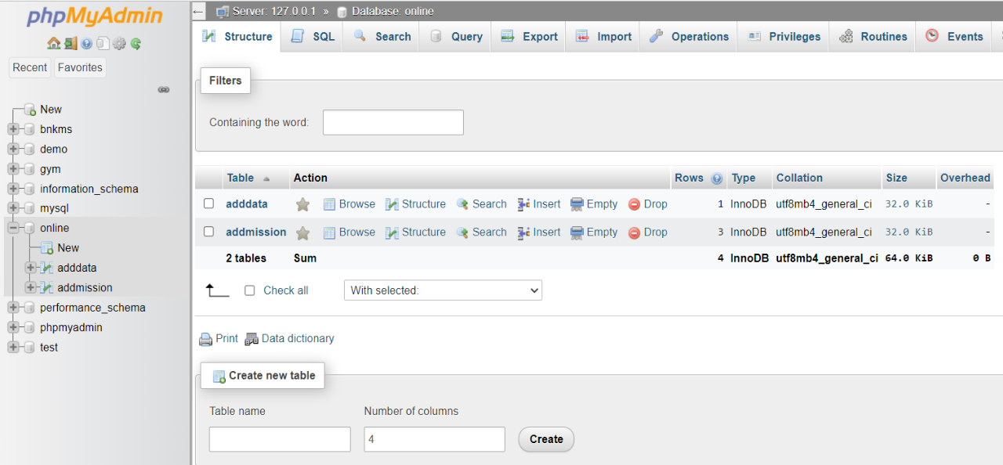

**Table: addmission**

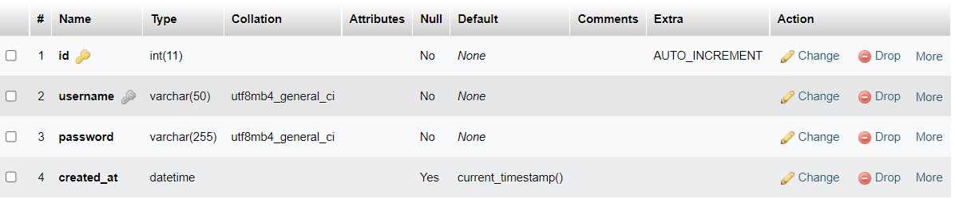

**Table: adddata**

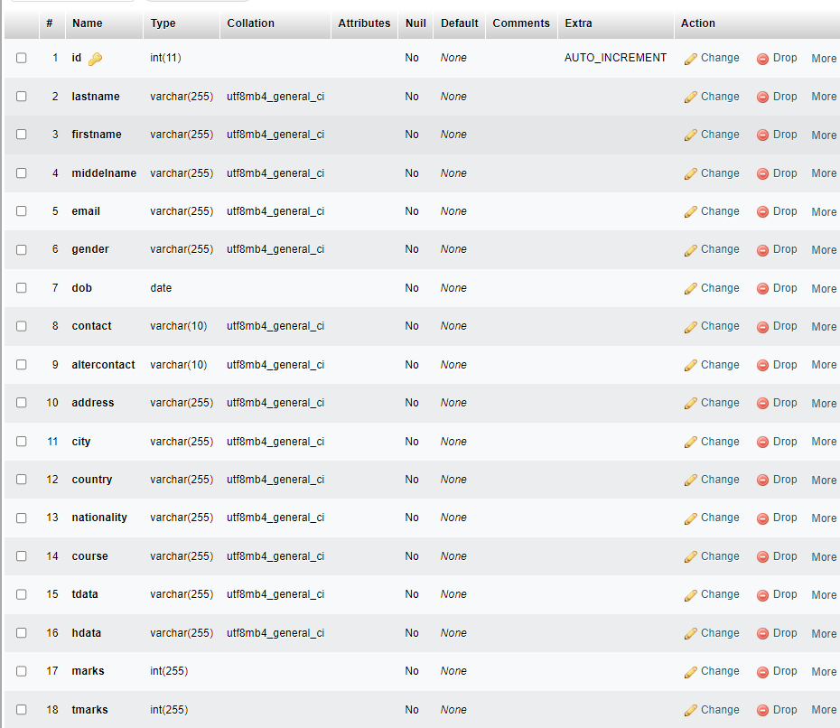

**6.2 Directory Structure**

htdocs

Online

Files

Query Text

Bootstrap

Images

CSS

1. Config.php
2. Login.php
3. Resig.php
4. Welcome.php
5. Course.php
6. Addmission.php
7. Index.php
8. About.php
9. Reset-password.php
10. Logout.php
11. Insert.php
12. Delete,php
13. Login.css
14. Resig.css
15. Reset.css
16. Welcome.css
17. About.css
18. Addmission.css
19. Course.css
20. Index.css

**6.3** **Input Design**

* 1. **Login**

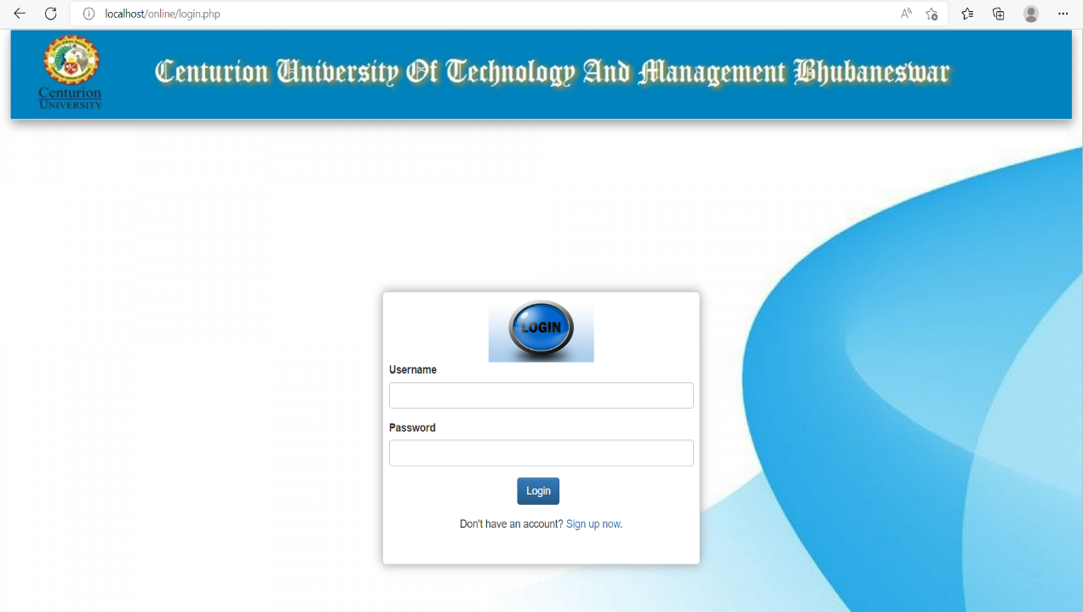

* 1. **Registration**

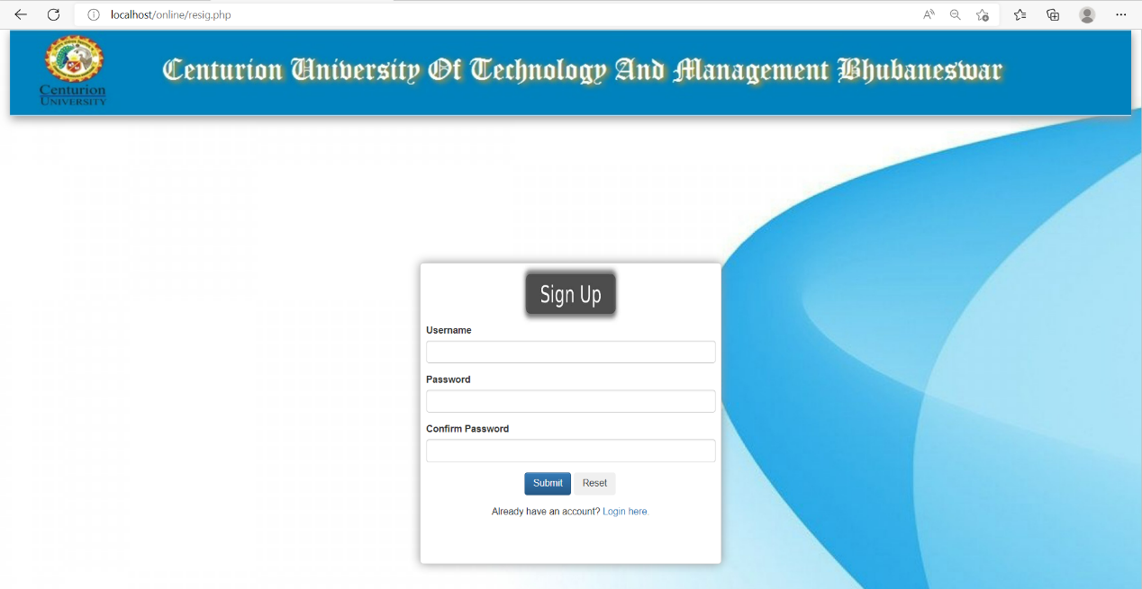

* 1. **Addmission Form**

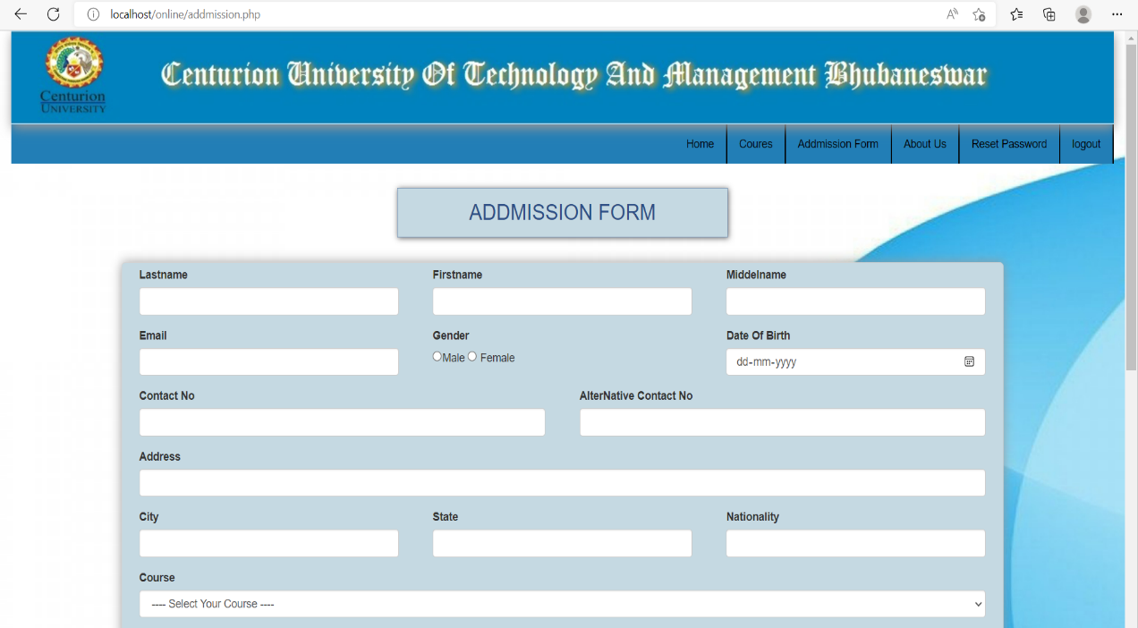

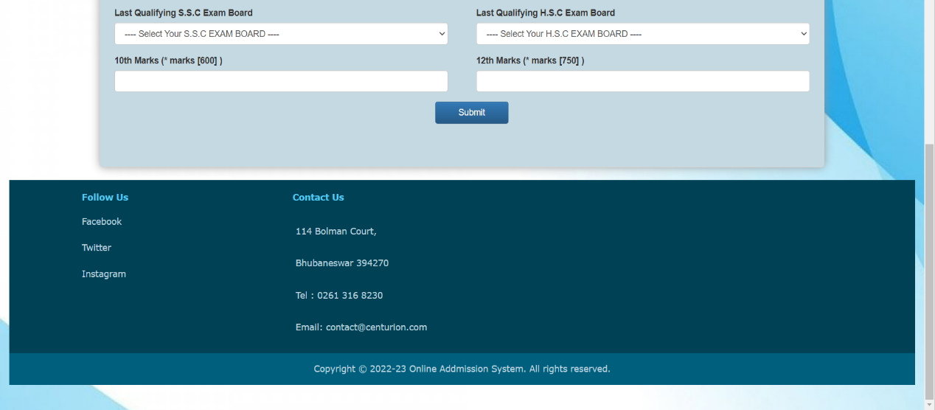

* 1. **Reset-password**

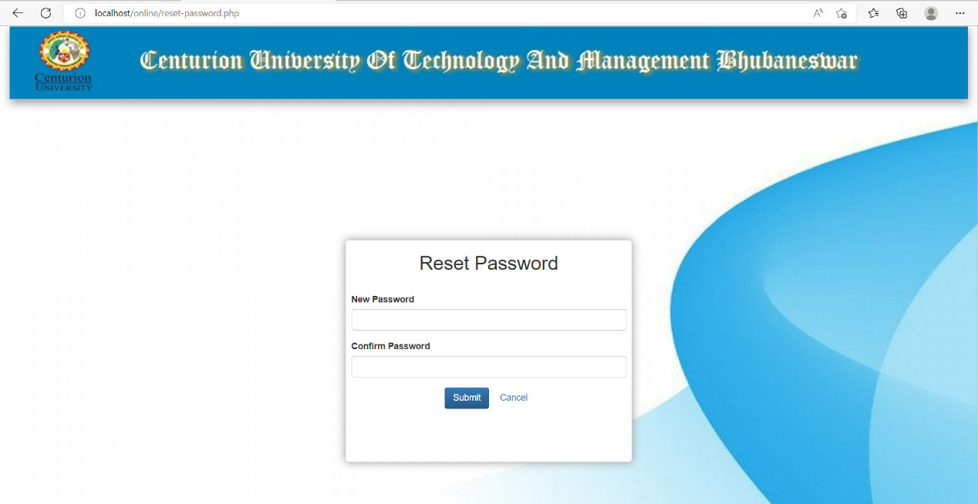

* 1. **Index**

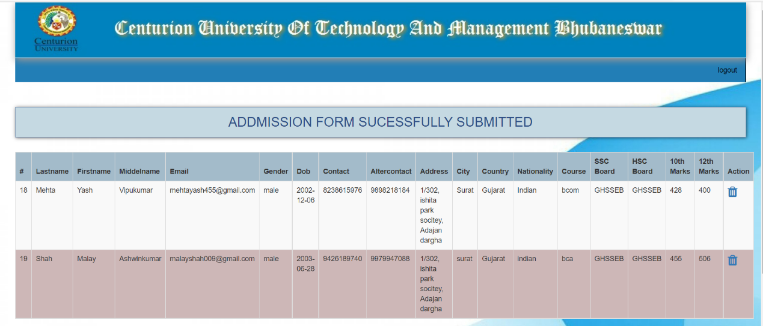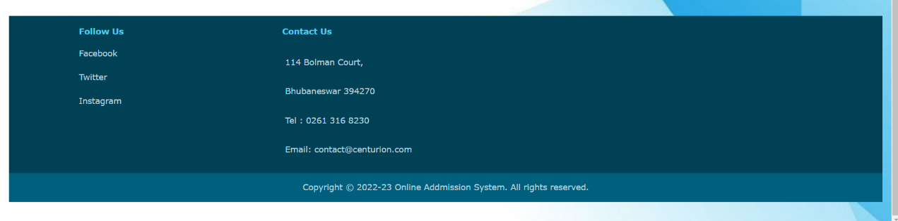

**6.4** **Output Design**

1. **Welcome**

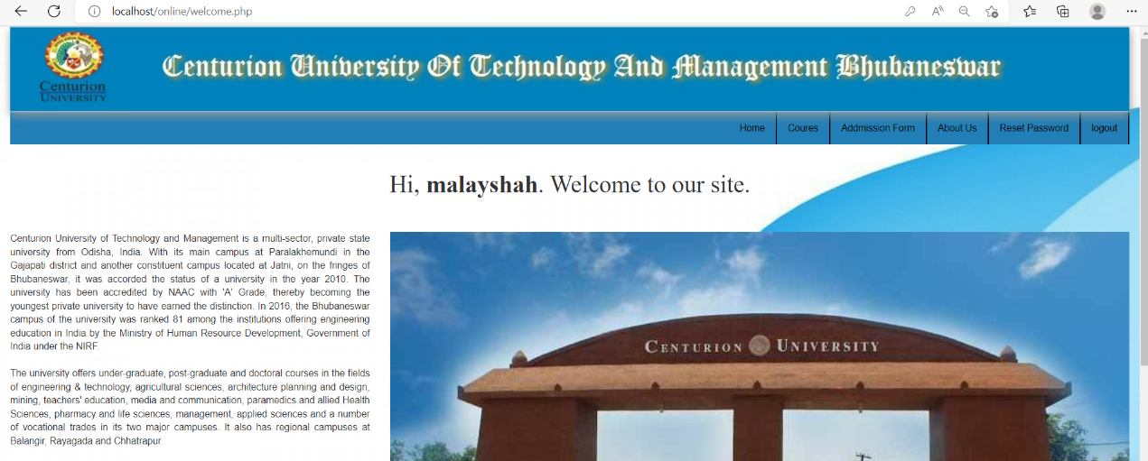

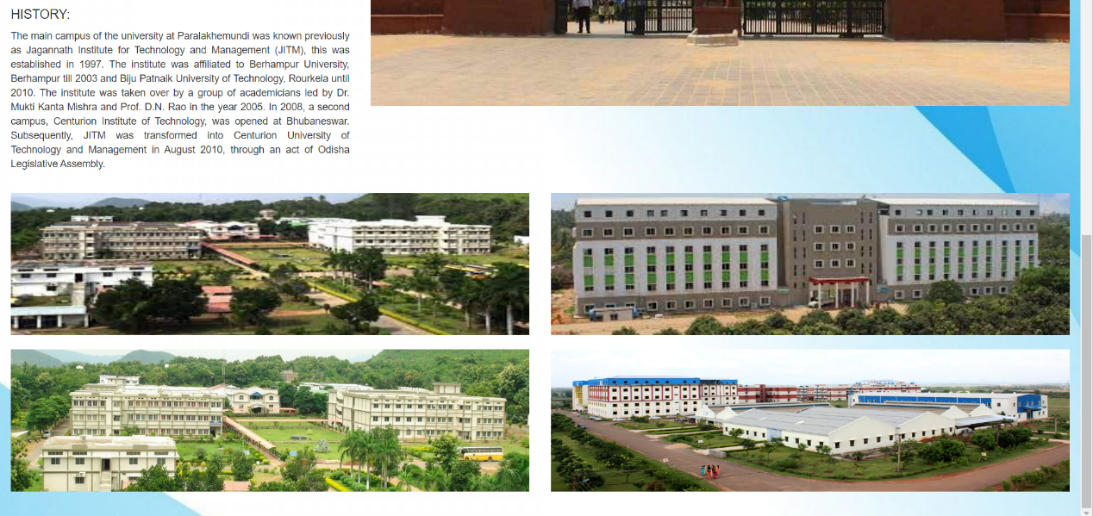

1. **Course**

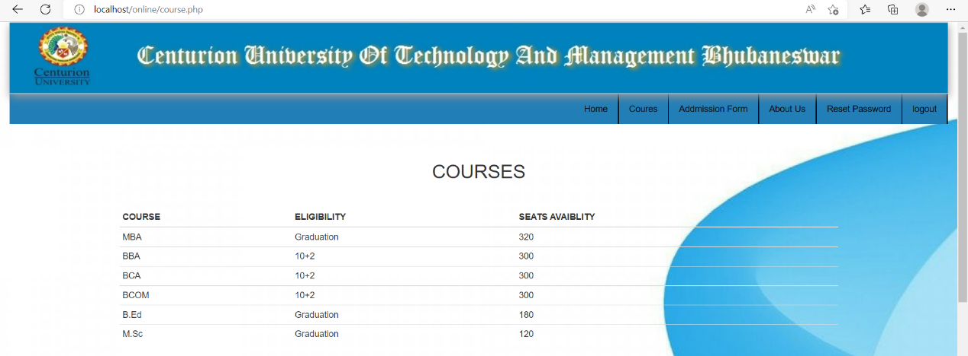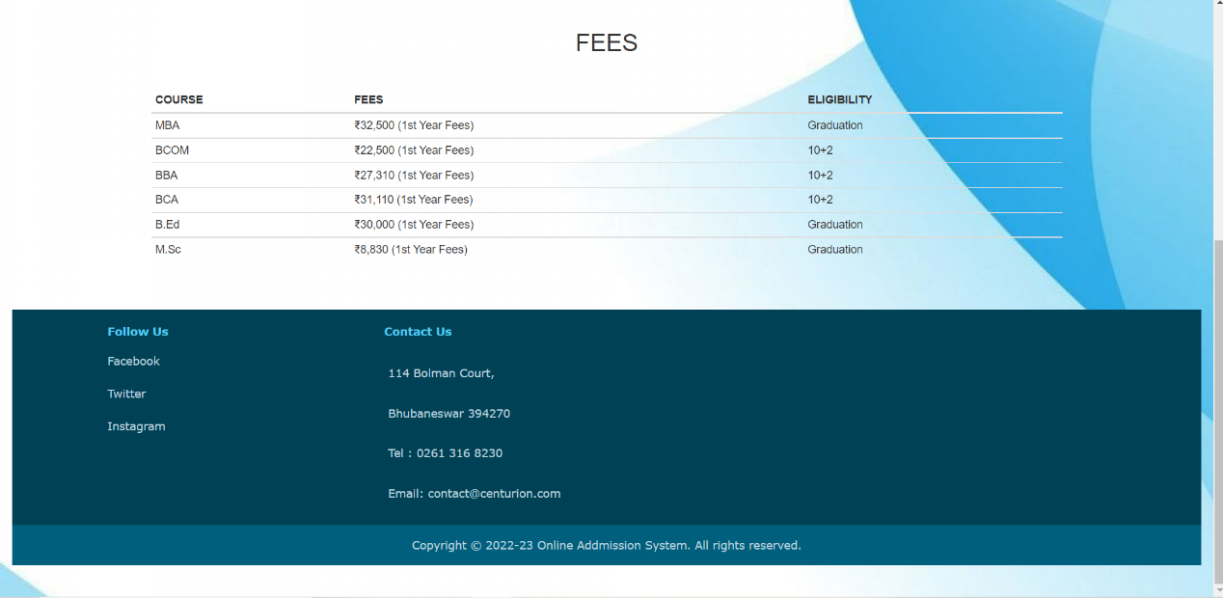

1. **About**

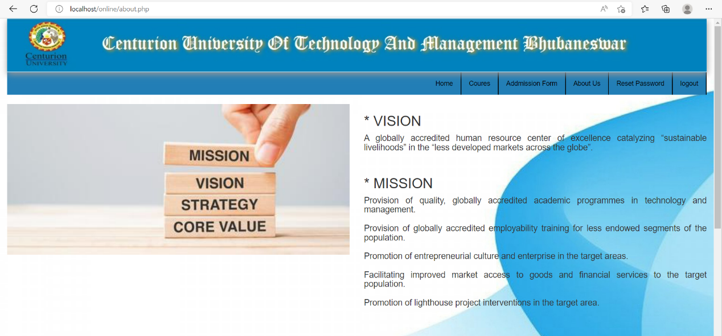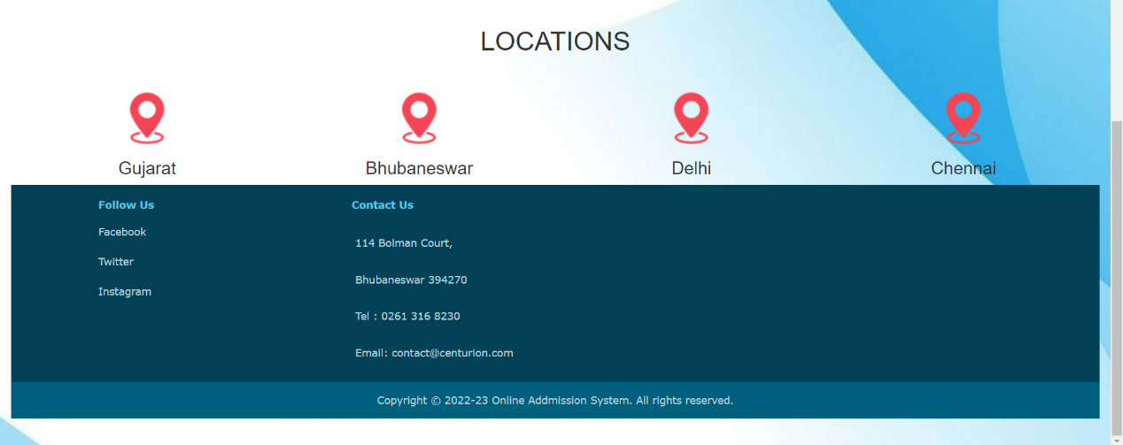

**Software Testing**

Software testing is a critical element of the software development cycle. The testing is essential for ensuring the Quality of the software developed and represents the ultimate view of specification, design, and code generation. Software testing is defined as the process by which one detects the defects in the software. Testing is a set of activities that work towards the integration of entire computer-based system.

A good test case is one that has a high probability of finding an as-yet undiscovered error. A successful test is one such uncovers or finds such errors. If testing is conducted successfully, it will uncover errors in the software. It also demonstrates that software functions are being performed according to specifications and also behavioral and performance requirements are satisfied. For this, test plans have to be prepared. The implementation of a computer system requires that test data has to be prepared and that all the elements in the system are tested in a planned and efficient manner. Nothing is complete without testing, as it is vital success of the system.

* + - **Unit Testing**

Unit testing is carried out screen-wise, each screen being identified as an object. Attention is diverted to individual modules, independently to one another to locate errors. This has enabled the detection of errors in coding and logic.

This is the first level of testing. In this, codes are written such that from one module, we can move on to the next module according to the choice we enter.

* + - **System Testing**

In this, the entire system was tested as a whole with all forms, code, modules and class modules.System testing is the stage of implementation, which is aimed at ensuring that the system works accurately and efficiently before live operation commences. It is a series of different tests that verifies that all system elements have been properly integrated and perform allocated functions. System testing makes logical assumptions that if all parts of the system are correct, the goal will be successfully achieved. Testing is the process of executing the program with the intent of finding errors. Testing cannot show the absence of defects, it can only show that software errors are present.

* + - **Integration Testing**

This testing strategies combines all the modules involved in the system. After the independent modules are tested, dependent modules that use the independent modules are tested. This sequence of testing layers of dependent modules continues until the entire system is constructed.

Though each module individually, they should work after linking them together. Data may be lost across interface and one module can have adverse effect on another. Subroutines, after linking, may not do the desired function expected by the main routine. Integration testing is a systematic technique for constructing program structure while at the same time, conducting test to uncover errors associated with the interface. In the testing the programs are contructed and tested in the small segments.

**Limitations and Future Scope of Enhancements**

Computer Literacy and Internet Access - In India, though Internet penetration is rather high. Internet connectivity and speed issues are a major barrier. Most rural areas expertise high blackouts and electricity problems. This means, once more candidates in urban districts and square measures are placed at a big advantage.

Low Computer Literacy - Another major concern is the low rate of computer literacy in India. Current estimates say that solely concerning half dozen percent Indians are computer savvy. A fast shift to the net admission method is probably going to cause confusion and oppression among a good many candidates.

Security Concerns - The internet is a very vast network that requires a lot of expertise, time, and money to successfully monitor and disable all possible security threats. student admission would be very tricky because even the smallest security flaw could be exploited, causing severe damage and consequences. Hacker could tamper with students’ data. Online admission makes it very hard to ensure 100% safety.

Most rural areas expertise high blackouts and electricity problems. This means, once more candidates in urban districts and square measures are placed at a big advantage. Low Computer Literacy – Another major concern is the low rate of computer literacy in India.

**Future Scope of Enhancements**

* + - This can be implemented in less time for proper admission process.
    - Available 24*7 for addmission.
    - This can be accessed anytime anywhere, since it is a web application provided only an internet connection.
* An applicant should be do not able to fill up the form directly without any login. But a user id and password should be provided by registration details.
* Form structure should consist of all the data needed for registration.
* The total data for admitted students in the prescribed format should be sent to college after completion of admission process.

**References**

Website: <https://www.w3schools.com/>

Website: <https://www.tutorialspoint.com/>

Website: <https://www.youtube.com/>

Website: <https://fontawesome.com/>